December 20, 2013

Michael Scuse

Under Secretary for Farm and Foreign Agricultural Service

U.S. Department of Agriculture

1400 Independence Avenue S.W.

Washington, D.C. 20250

Ambassador Isi Siddiqui

Chief Agricultural Negotiator

Office of the U.S. Trade Representative

Executive Office of the President

600 17th Street N.W.

Washington, D.C. 20508

Dear Under Secretary Scuse and Ambassador Siddiqui:

This is to inform you that as of October 2013 nine of the major U.S. meat and poultry trade associations and the American Farm Bureau Federation joined together to form the “Meat and Poultry Industry Trade Policy Council” or the “MPITPC.” The purpose of the MPITPC is to provide a forum for monthly meetings/conference calls to exchange information about important international trade issues and barriers to trade in key markets around the world. One of our most important functions as a “Council” is to work together as representatives of the meat and poultry packers, processors, livestock producers and ranchers to advise and consult with you and your respective staffs at USDA and USTR on existing and pending trade negotiations as well as current impediments to trade. Our shared goal is to facilitate trade in meat and poultry products by eliminating or mitigating barriers to trade in all meat and poultry products.

Members of the MPITPC include: American Farm Bureau Federation (AFBF), American Meat Institute (AMI), National Cattlemen’s Beef Association (NCBA), National Chicken Council (NCC), National Pork Producers Council (NPPC), National Turkey Federation (NTF), North American Meat Association (NAMA), USA Poultry and Egg Export Council (USAPEEC), U.S. Hide, Skin and Leather Association (USHLA) and the U.S. Meat Export Federation (USMEF).

The MPITPC will rotate “secretariat” responsibilities among members as follows:

October – December, 2013: American Meat Institute

January – March, 2014: National Pork Producers Council

April – June, 2014: National Cattleman’s Beef Association

We look forward to working with both of you to expand market opportunities for meat and poultry products worldwide. Please feel free to contact us as a group for consultations and/or review of trade issues which span the meat and poultry industry. We, in turn, will be in touch with you about specific issues of interest to the industry. For example, a separate letter will follow regarding MPITPC’s proposals for the Transatlantic Trade and Investment Partnership negotiations.

If you have questions, please call Bill Westman (202) 587-4244, Nick Giordano (202) 347-3600 or Kent Bacus (202) 879-9109.

Sincerely,

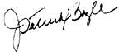 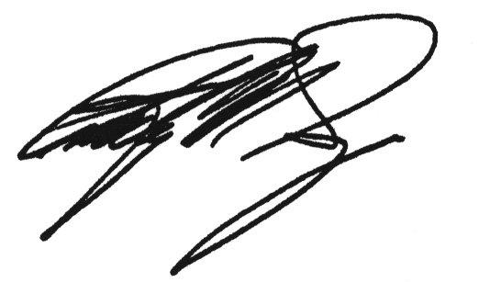

J. Patrick Boyle Phil Seng

President and CEO President and CEO

American Meat Institute U.S. Meat Export Federation

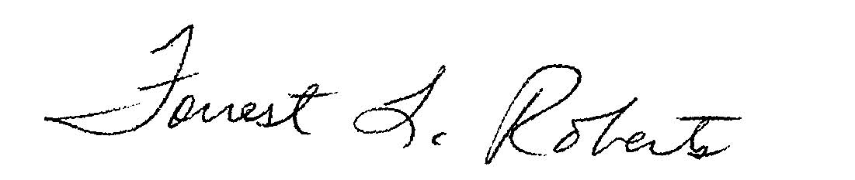 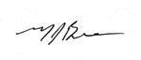

Forrest L. Roberts Mike Brown

Chief Executive Officer President

National Cattlemen’s Beef Association National Chicken Council

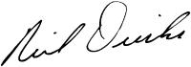 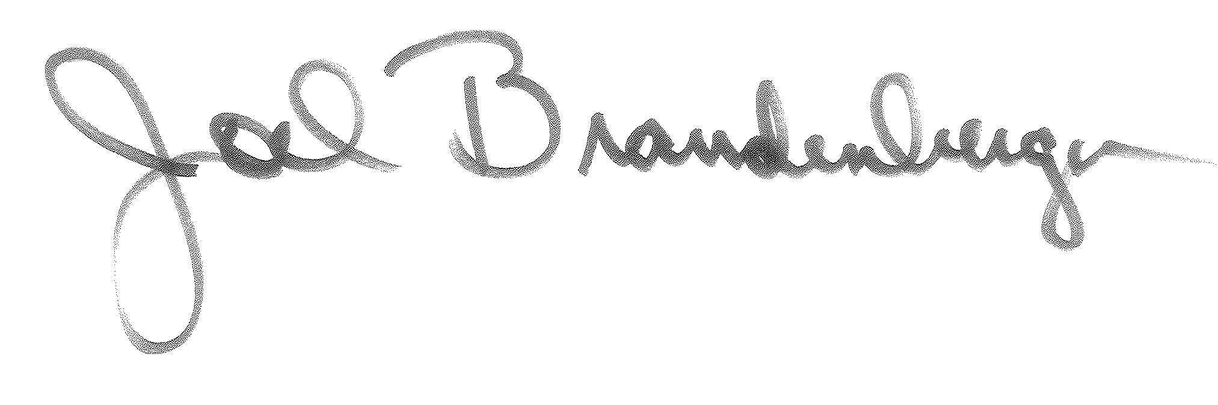

Neil Dierks Joel Brandenberger

President President

National Pork Producers Council National Turkey Federation

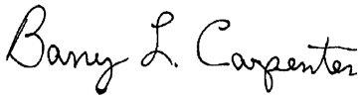

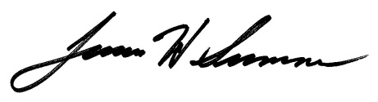

Barry Carpenter Jim Sumner

President President

North American Meat Association USA Poultry and Egg Export Council



John Reddington

President

U.S. Hide, Skin and Leather Association

cc: Thomas Vilsack, Secretary of Agriculture

Ambassador Michael Froman, U.S. Trade Representative

Darci Vetter, Deputy Under Secretary, FFAS, USDA

Sharon Boomer, A/USTR Agricultural Affairs

Suzanne Heinen, Senior Counselor to the Under Secretary

Phil Karsting, Administrator, Foreign Agricultural Service